**IoT Case Study**

**Drones For Agriculture**

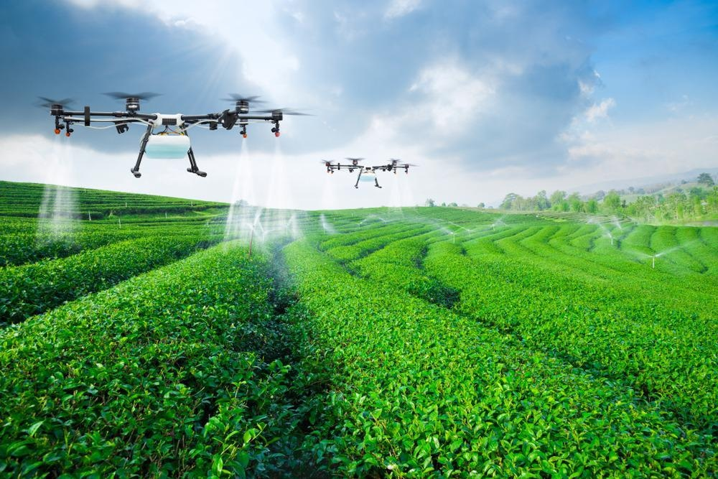

**Adithya M**

**PES1UG20CS621**

**Section: K**

**Introduction:**

* Agricultural drones are a class of unmanned aerial vehicle (UAV). Agriculture monitoring is among the most mature use cases for drones.
* Drones can cover 10 times more land than a ground-based observer in the same amount of time due to their sky-to-earth perspective and ability to fly over barriers.
* The flight of agriculture drones may be controlled with various degrees of autonomy, ranging from the remote control by an operator located in the vicinity to fully autonomous flight coordinated by onboard computers.
* In addition to cropland, drones are also deployed to monitor aquaculture and forests, as well as poultry, cattle, and other livestock.

**Business Perspective:**

* Increased yields: Drones with machine vision and specialized algorithms can be used to find yield limiting problems.
* Time savings: Drones reduce the use of human labor in surveying crops and can cover up to 10 times more ground in a given amount of time. Drones are particularly effective in large farms or farms with complex geography or natural barriers such as streams and hedges.
* Water efficiency and other environmental benefits: Thermal cameras are able to detect cooler, well-watered field regions as well as dry hot patches.
* Farmers can use the data to adjust field irrigation and avoid wasting excess water.

**Metrics for Measuring the Impact of System:**

* Increased yield
* Reduction in raw material usage
* Labour

**Technology:**

* Sensors: Drones collect information largely based on the light reflected by the crop below. Two types of sensors are installed most frequently on drones: **Thermal** and **Hyper-spectral** sensors.
  + Thermal sensors can read the radiated temperature of an object. A thermal sensor might help identify how plants are using water, as those with access to more water appear cooler in an image.
  + Hyper-spectral sensors record many wavelengths of both visible and invisible light. The promise of these sensors is that they might be able to identify the specific type of plant merely by measuring the color of light that it reflects, which would make it easy to pick out things like herbicide-resistant weeds.
* Communicationsystem**:** The communication system varies based on the what kind of flight controller the drone uses. In most cases, the data communication protocols are **ZigBee mesh network**. Many drones can operate a flight pattern without connectivity, which is useful in large areas with poor reception.
* Data Collection: Data is collected as the drone flies around the environment. The height of the drone, and its field of vision depends on the type and quality of the sensor. Data is generally relayed to the **cloud** after the drone lands. While drones can transmit data in flight, this is often cost prohibitive.

**Challenges:**

* Too much data: One of the primary challenges for is understanding how to filter and interpret the data in order to derive insights that can guide better decision making. This is particularly true when light or chemical analyses are deployed.
* Automation: Setting up automated schedules requires basic programming capabilities that many farmers (users) lack.
* Maintenance**:** Drones are durable but when in heavy use the require regular maintenance. Storms, attacks by wild birds, and collisions with debris can all damage either the drone or sensors installed on the drone.

**Specific Use Cases:**

* Soil and field analysis
* Planting
* Crop spraying
* Crop monitoring
* Irrigation

**References:**

* <https://www.researchgate.net/publication/358733839_Case_study_on_Agricultural_Autonomous_Drones>
* <https://medium.com/aerial-acuity/case-study-ce39c9f44e48>